**Adding a Garden Device (Thing) to AWS IoT**

1. Login to AWS Management Console

**Link**: <https://console.aws.amazon.com/console/home>

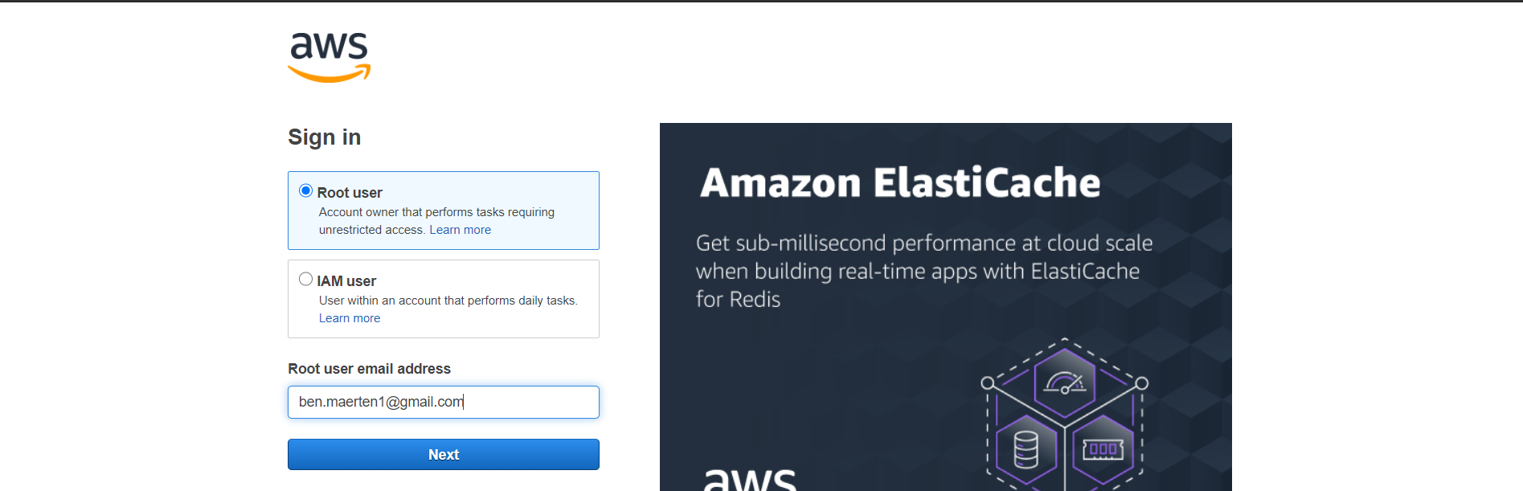

1. Go to **AWS IoT Core**

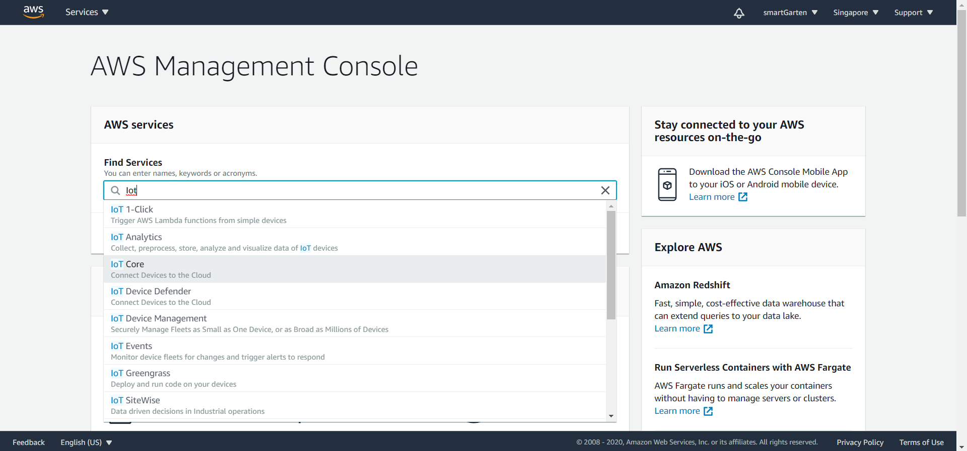

1. Navigate to **Manage > Things** in the sidebar

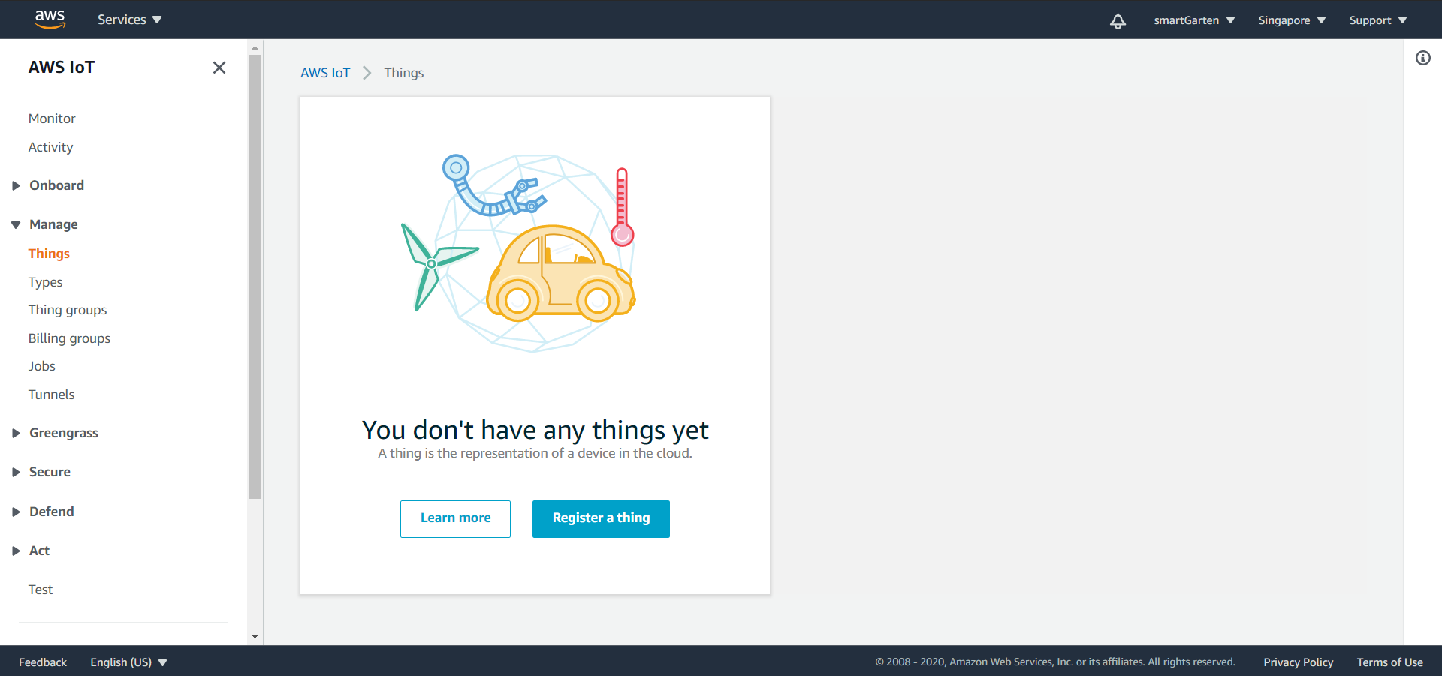

1. In this screen, you will see list of initialized garden devices. To add another garden device, click [**Create**] button.

**Note**: *smartGarten1* is already created.

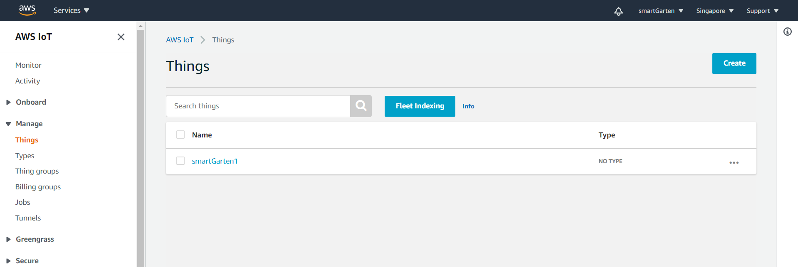

1. Click [**Create a single thing**]

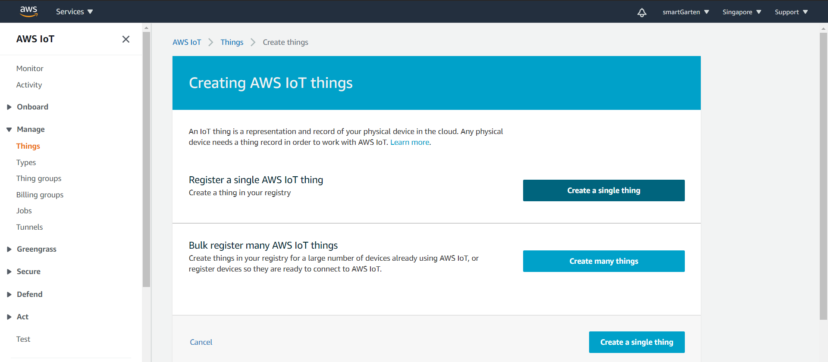

1. Enter thing name with prefix ‘**smartGarten’**. *Ex. smartGarten2.*

**Note**: The prefix *smartGarten* is important as policies in the mobile app can access things with name as such.

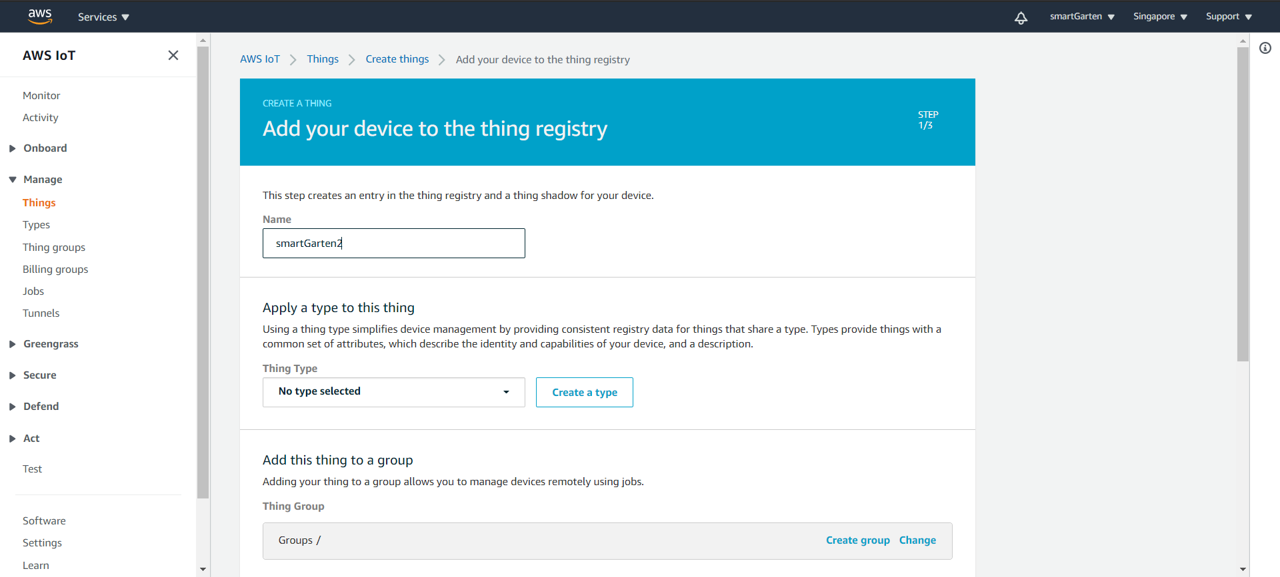

1. In [**Add this thing to a group**] section, click [**Change**] button. This will pull up thing group list. Click on **smartGarten**.

**Note**: This is an important step too for this will include the thing you will create to the dropdown list in the smartGarten mobile app.

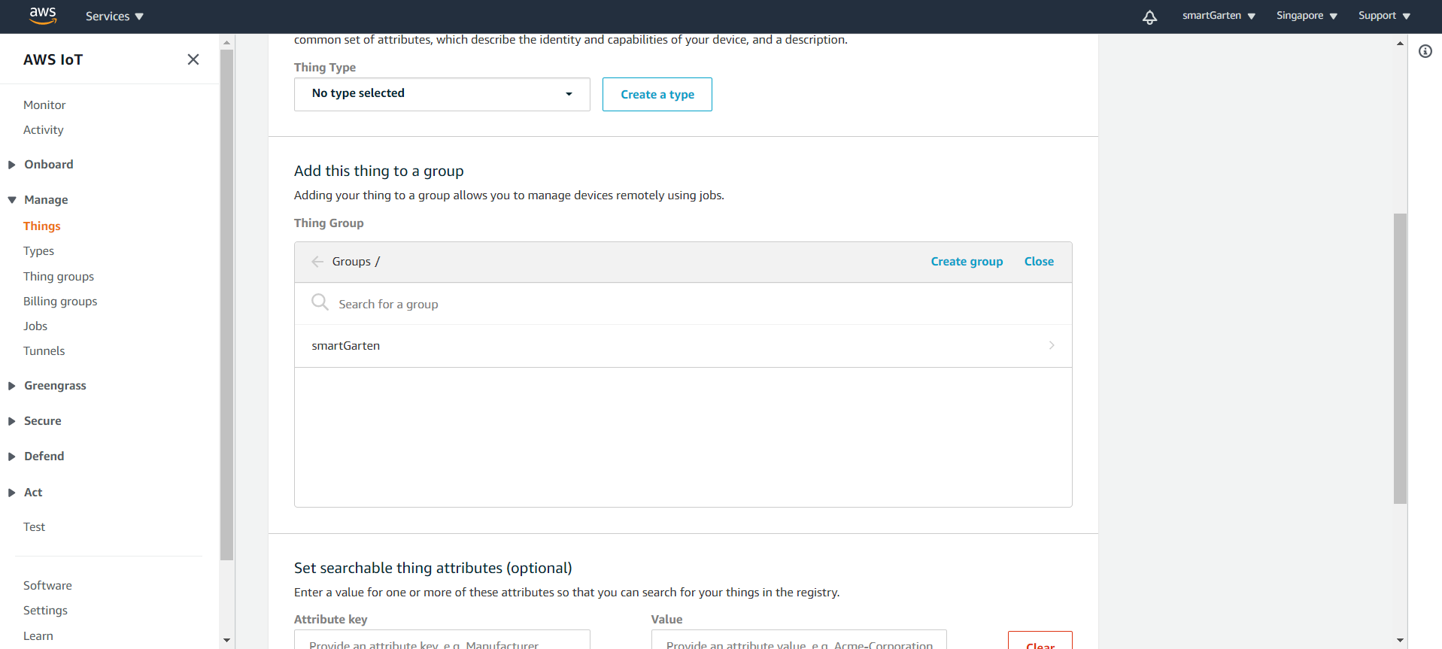

1. Proceed to next step. On the [**Add Certificate**] screen, click [**Create thing without certificate**].

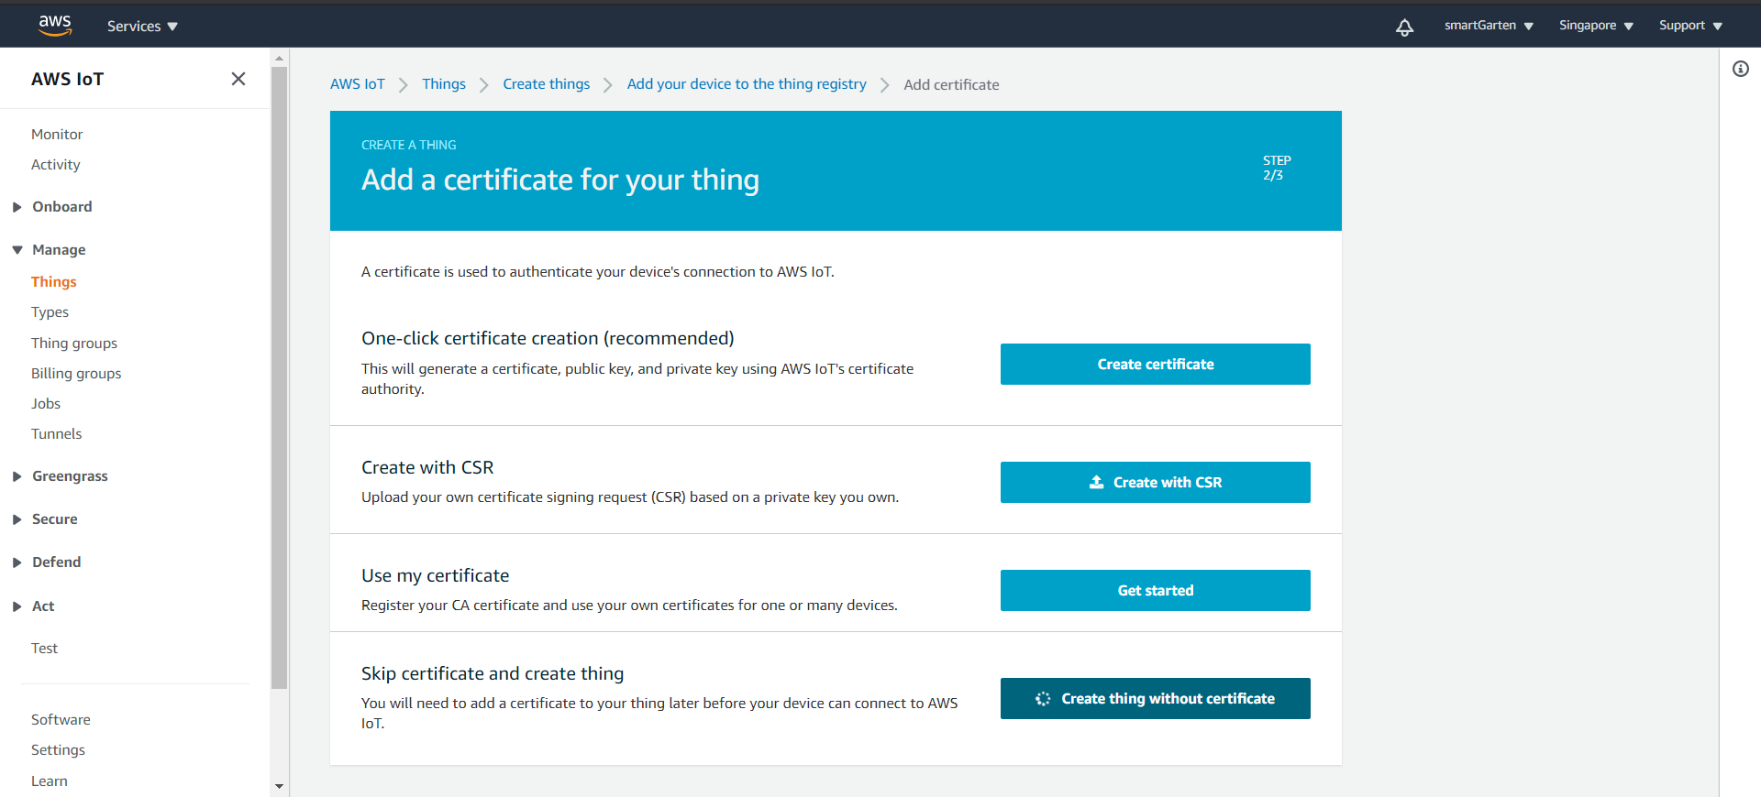

1. This successfully creates a thing. One last step is to attach this thing to the active certificate registered to our Arduino code. You can do this by going to [**Certificates**] in the sidebar.

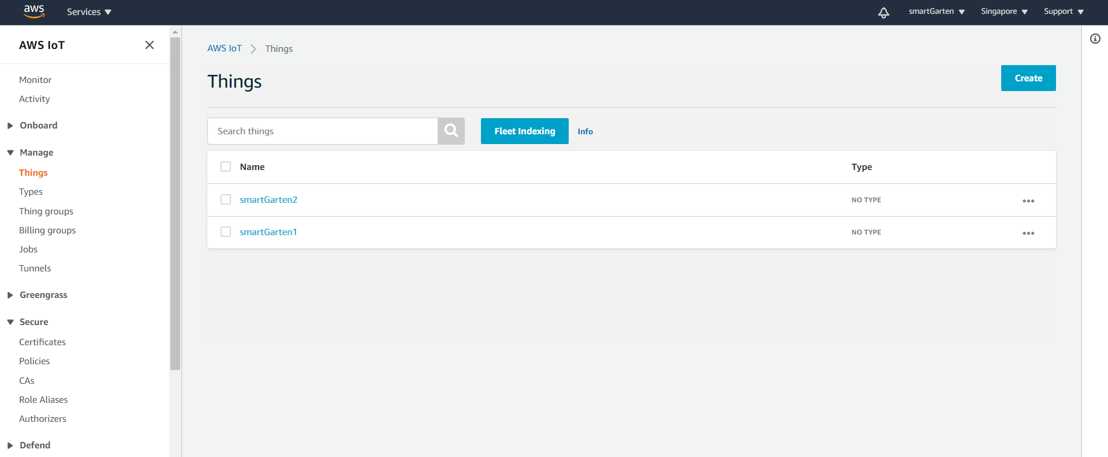

Select the only one certificate in the list. (Starts with ***e2648***)

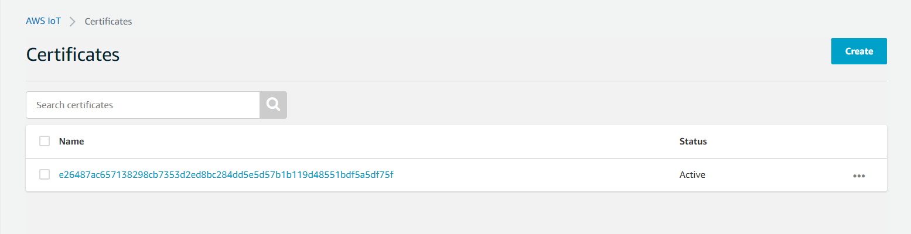

Select [**Actions**] then [**Attach policy**]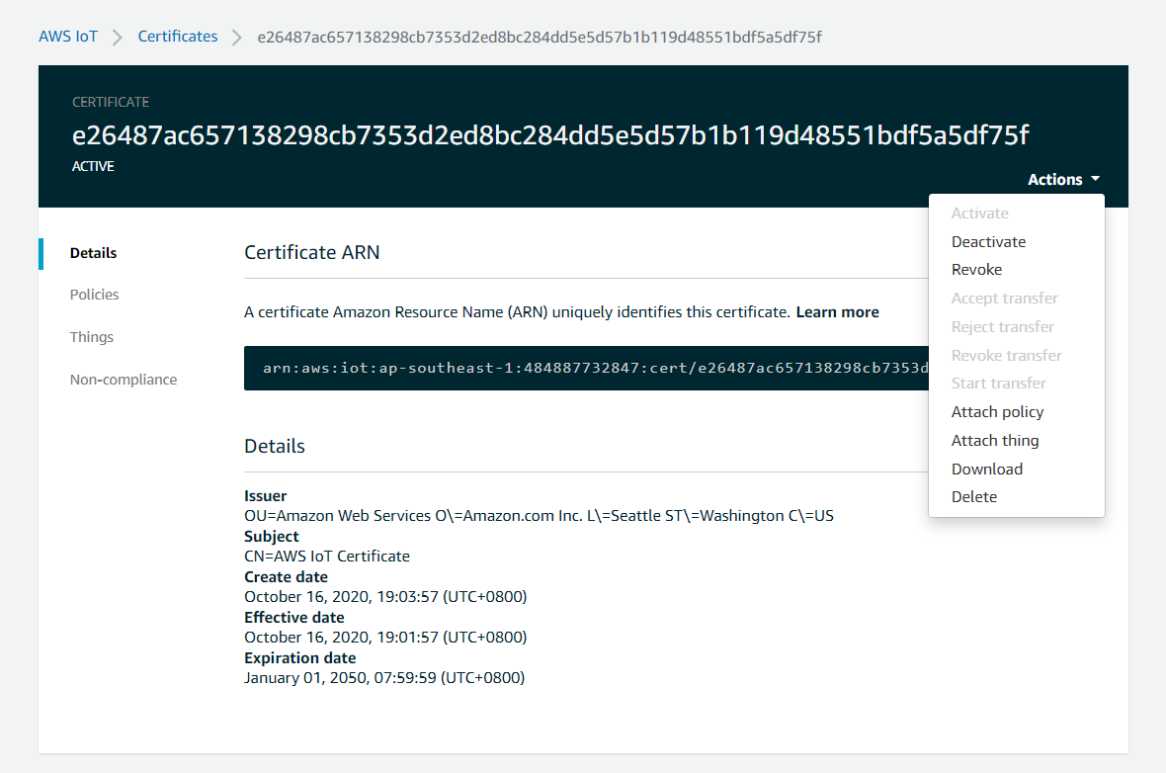

Check newly created things you have created. Then finally click [**Attach**]

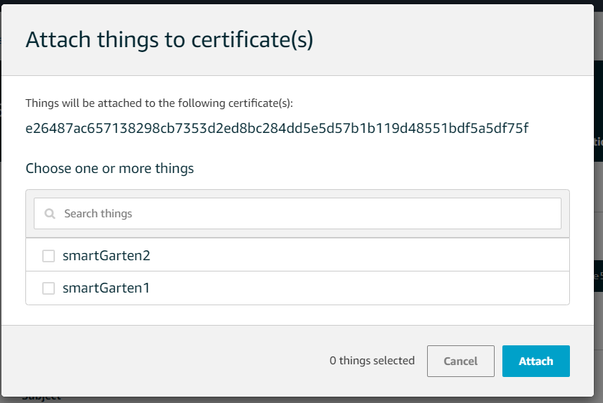

1. After successfully creating a thing, you can now use it as **THINGNAME** in Arduino code. That is in **line 5 in secrets.h file**.

**Note**: Names that you can use as **THINGNAME** should be registered to AWS IoT. For example, if you change **THINGNAME** in Arduino code to *smartGarten3*, this thing should also be registered in AWS IoT by following the previous steps.